Architectural/Engineering “Punch List” Documentation
Software Design Document (SDD)
10/14/2026

Nathan Rubiano, Muhammad Khan, Satya Thakur


Table of Contents

Software Design Document……………………………………………………………………………1
Table of Contents………………………………………………………………………………………..2
1. Introduction……………………………………………………………………………………………3
1.1 Purpose of this Document…………………………………………………………………..3
1.2 References…………………………………………………………………………………...3
2. System Architecture…………………………………………………………………………………4
2.1 Architectural Design…………………………………………………………………………4
2.2 Decomposition Description…………………………………………………………………7
3. Persistent Data Storage……………………………………………………………………………..9
3.1 Database Descriptions………………………………………………………………………9
3.2 File Descriptions……………………………………………………………………………10
4. Requirements Matrix……………………………………………………………………………….12
Appendix………………………………………………………………………………………………...13
A - Customer and Contractor Agreement……………………………………………………13
B - Peer Review Sign-Off………………………………………………………………………14
C - Document Contributions…………………………………………………………………...14

- Introduction

1.1 Purpose of this Document
- The purpose of this document is to detail how the Architectural “Punch List” Software is being developed from a backend point of view. It aims to describe the functional and non-functional requirements in order to turn them into implementable design. This document will outline the software/system architecture and how it will satisfy project requirements. Also this document will break down database and file components of the software into diagrams and readable tables. The intended audience of this document are the product owner and stakeholders of the project to ensure that the developers are fulfilling the coding needs of the project. This document will also be used as a reference for developers to understand the needs and requirements of the system.

1.2 References
- Software Requirements Specification Version 2.0: https://docs.google.com/document/d/1H9m07XzFU0t6ub8QJV2kXuiAVoHQt3JpW_bxdxoKbaw/edit?usp=sharing
- FastAPI Asynchronous Framework Documentation: https://fastapi.tiangolo.com
- React 18 & HTML5 Canvas Documentation: https://react.dev
- Mozilla PDF.js Plan Rendering Engine: https://mozilla.github.io/pdf.js
- Dexie.js IndexedDB Client-Side Persistence: https://dexie.org
- Python-SocketIO Real-Time Engine: https://python-socketio.readthedocs.io
- SQLAlchemy 2.0 Core Database Engine: https://docs.sqlalchemy.org
- ReportLab Vector PDF Drawing Generation: https://www.reportlab.com

- System Architecture

2.1 Architectural Design
- The system is built with JavaScript (React 18 with Vite) on the client and Python (FastAPI 0.115+) on the server, developed and run in modern Linux and Windows environments. Users access the application through a standard web browser (Google Chrome, Apple Safari, Microsoft Edge). Target hardware is standard field tablets (Apple iPad, Samsung Galaxy Tab, Microsoft Surface), smartphones, and desktop workstations.

Because the program is delivered as a tablet-first Progressive Web Application, it operates online against cloud backends and offline in low-connectivity jobsites. When disconnected (for example in concrete basements or subterranean garages), it caches all sheet drawings, punch items and photos locally in IndexedDB through Dexie.js, and queues mutations that are replayed automatically when connectivity returns.

The client is entirely contained in the browser runtime: React functional components, HTML5 Canvas, and standard ECMAScript libraries, namely Mozilla PDF.js (multi-page plan sets), Dexie.js (transactional caching), and the Socket.IO client (bidirectional real-time sync). The client uses its own normalized coordinate model: raw viewport pixel taps are converted into resolution-independent floating-point tuples (x_percent, y_percent) in [0.0, 100.0]%. Georeferenced pins therefore stay at the exact physical location whether the sheet is viewed on an iPad Mini, a 12.9-inch iPad Pro, a 4K monitor, or exported to PDF.

On the backend, FastAPI runs on the Uvicorn ASGI server with SQLAlchemy Core for database access. The backend implements full multi-tenant project isolation and Role-Based Access Control. Authentication uses cryptographically signed JSON Web Tokens (HMAC-SHA256) that carry user claims and enterprise roles. Persistence follows a dual-database strategy: PostgreSQL in production for enterprise concurrency, and SQLite for lightweight local deployment and automated CI/CD regression testing.

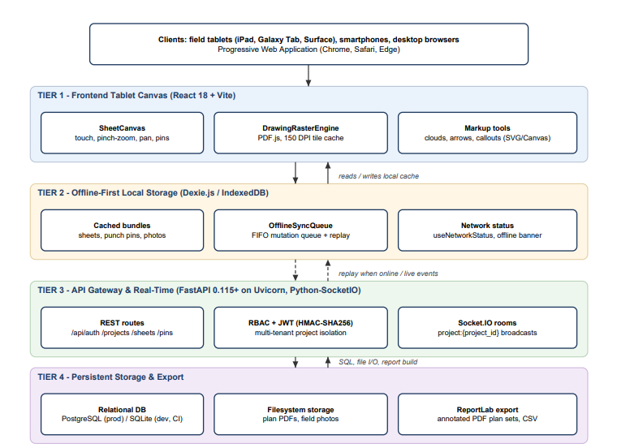

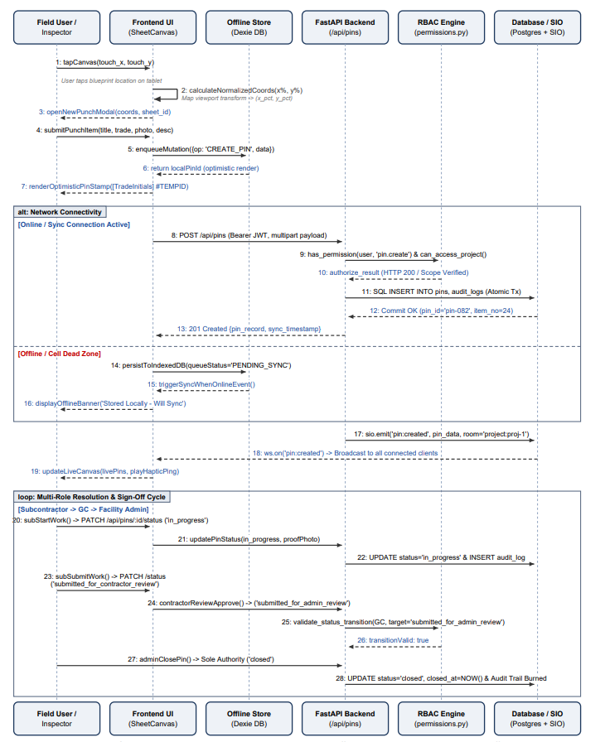

2.2 Decomposition Description
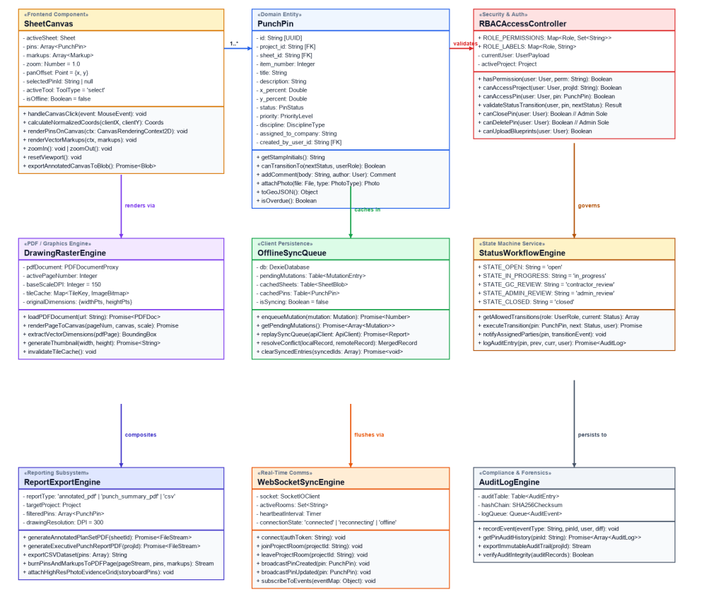

Subsystem Descriptions:

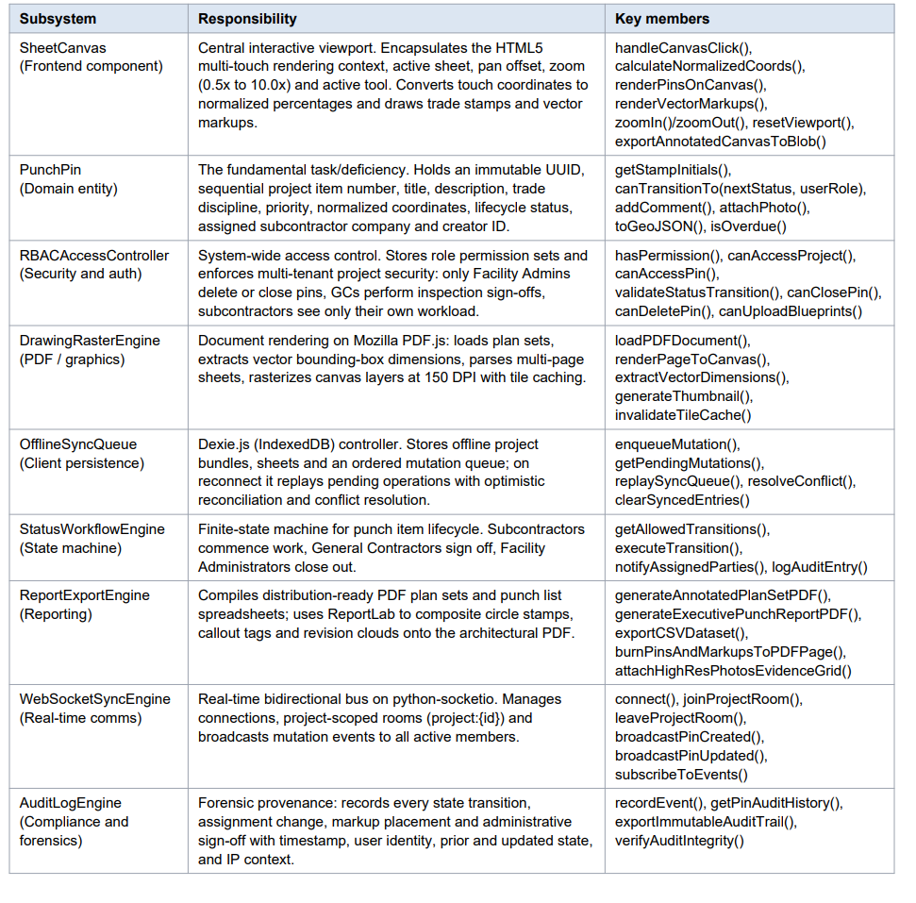
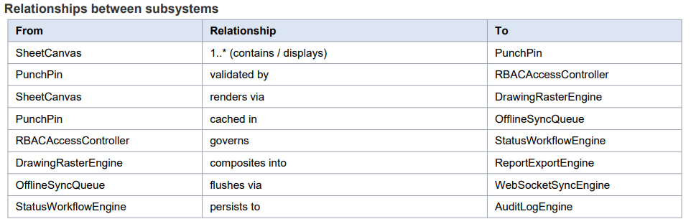

- Persistent Data Design

3.1 Database Descriptions

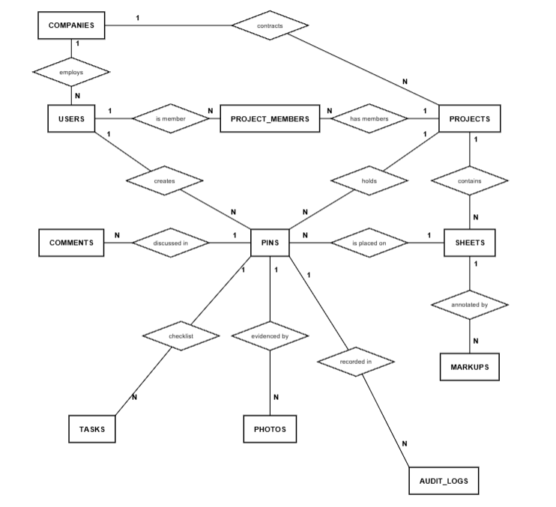
This is an Entity-Relationship Diagram of our database. The tables and fields that follow document everything the program stores in its relational environment. The schema has twelve tables; PostgreSQL is used in production and SQLite for local and CI deployments

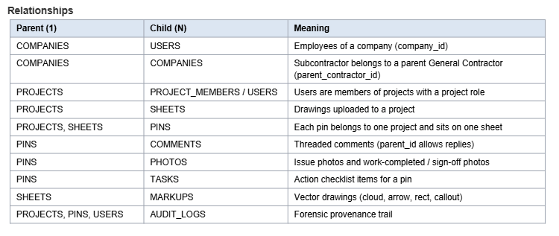
3.2 File Descriptions

For document ingestion and binary serialization, the system uses a function called burn_pins_and_markups_to_pdf. It translates normalized pin coordinate tuples directly into PostScript vector points on native PDF plan sheets and merges the result into the original drawing. The production implementation is shown below.

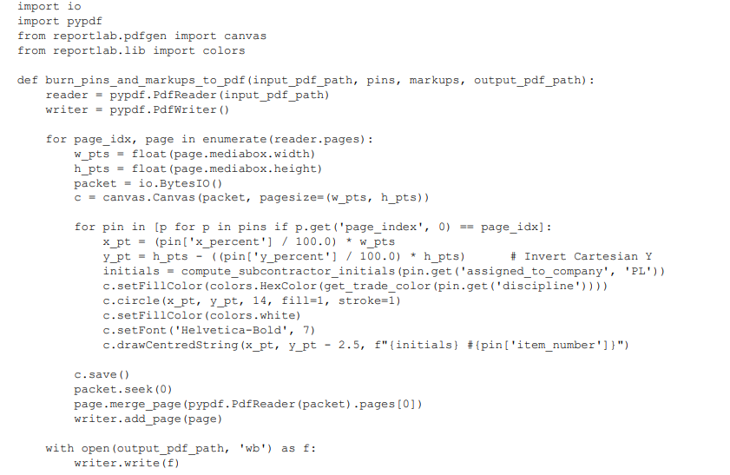
The function reads each page of the plan set, takes its MediaBox dimensions, draws a transparent ReportLab overlay containing the circle stamp, trade initials and item number of every pin on that page, and merges the overlay onto the page, so stamps are burned into the PDF as vector graphics.

Implementation notes
- The markups argument is part of the interface for revision clouds, arrows and callouts. They are drawn with the same de-normalization applied to the points in each markup's coordinates_json (the listing above shows the pin pass).
- page_index maps each pin to a page of the sheet's PDF; plan sets with a non-zero MediaBox origin or a /Rotate entry need the offset and rotation applied before de-normalizing.
- compute_subcontractor_initials() derives the stamp initials from the assigned company name ('PL' is the fallback) and get_trade_color() maps the discipline to a high-contrast stamp color.

Coordinate transformation model
Forward mapping (tablet touch to normalized tuple), clamped to the sheet:
x_percent = clamp(((touch_clientX - canvas_rect.left - pan_offsetX) / (base_width * current_zoom)) * 100.0, 0.0, 100.0)
y_percent = clamp(((touch_clientY - canvas_rect.top - pan_offsetY) / (base_height * current_zoom)) * 100.0, 0.0, 100.0)

Inverse mapping (normalized tuple to PDF points for export and standard vector readers):
pdf_point_x = (x_percent / 100.0) * pdf_media_box.width_points
pdf_point_y = pdf_media_box.height_points - ((y_percent / 100.0) * pdf_media_box.height_points) # invert Cartesian Y
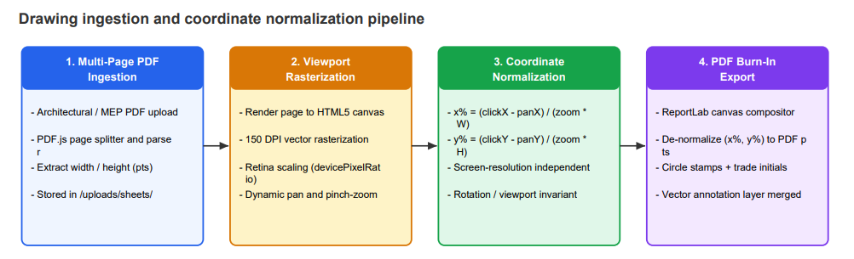

- Requirements Matrix
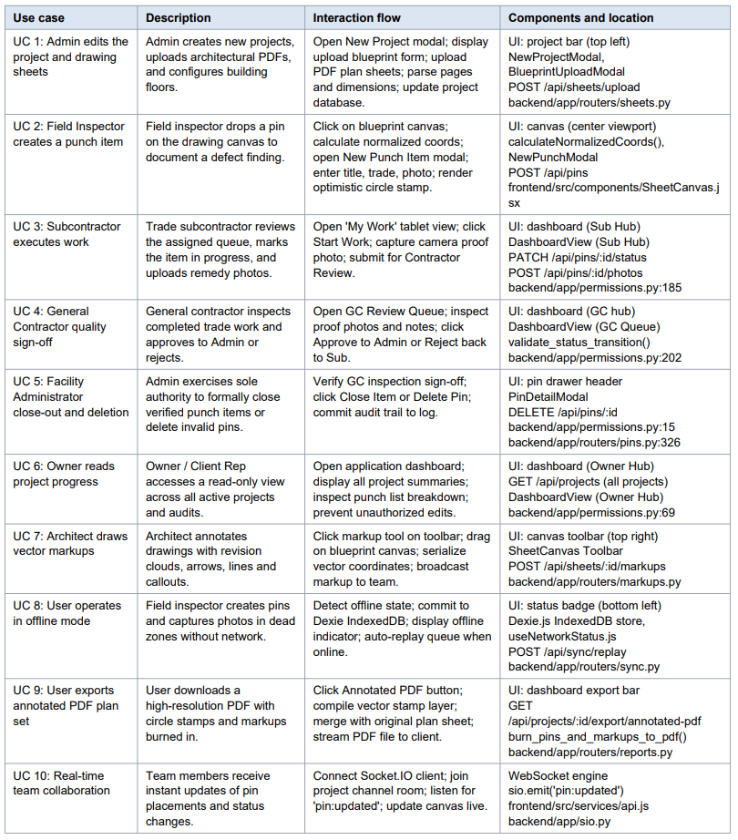
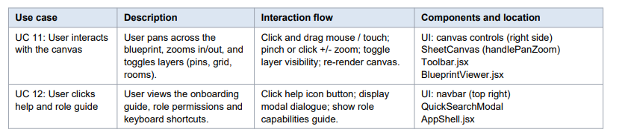

Appendix

A - Customer and Contractor Agreement
- By signing this document, the customer and developers agree to the details specified in this document such as the project’s scope, functional and non-functional requirements. In addition, they agree to collaborate in the process of developing the software over the course of the development lifecycle. Should the customer need to make changes to the document, they will request the development team to do so by contacting them via UMBC email to request the changes.

Customer:

Name | Signature | Date | Comments

Team:

Name | Signature | Date | Comments
Nathan Rubiano |  | 10/14/2026
Satya Thakur |  | 10/18/2026
Muhammad Khan |  | 10/18/2026

B - Peer Review Sign-Off
- By signing here, the development team continues to agree to work together and collaborate on the processes outlined in this document. If any issues remain in need of addressing, a team member shall refrain from signing until it is resolved.

Name | Signature | Date | Comments
Nathan Rubiano |  | 10/14/2026
Satya Thakur |  | 10/18/2026
Muhammad Khan |  | 10/18/2026

C - Document Contributions
- Contributions to this document came from: Nathan Rubiano, Satya Thakur, and Muhammad Khan

